BIOLOGY FOR ENGINEERS
Case Studies on Fermentation of Streptomycin

Arav Arun | Division – A | Roll no - 16010125013 (A-13) | BTech. Computer Engineering

1. INTRODUCTION
Fermentation Technology: A discipline that converges from the scientific fields, harnessing microbial metabolic capabilities to generate product of commercial importance in the pharmaceutical, chemical, food, agricultural, and energy sectors using regulated bioprocessing operations.
Applications of Fermentation in Industrial Biotechnology: Production of biomass by microbes, synthesis of primary and secondary metabolites, biotransformation of chemicals, production of recombinant proteins, and applications in bioremediation.
Streptomycin: The first aminoglycoside antibiotic and first successful medication for tuberculosis treatment. An antibiotic bactericide that inhibits bacterial protein synthesis by binding to the 30S ribosomal subunit. Selected as historically significant as the first antibiotic isolate from an actinomycete, ongoing clinical use in the therapy of multidrug-resistant tuberculosis, and as a member of the class of secondary metabolite complex biosynthesis.

2.BIOCHEMICAL PROCESS
Microorganism Used: Streptomyces griseus, a soilborne, Gram-positive, filamentous bacterium. Industrial mutants derived by traditional mutation and screening provide much higher yields and superior fermentation characteristics.

Fermentation Pathway: Streptomycin is a secondary end-product formed during the transition from exponential to stationary phase under stress conditions of nutrient.
Synthesis constructs three components: streptidine, streptose, and N-methyl-L-glucosamine. Glucose-6-phosphate is reduced to myo-inositol, oxidized, transaminated, and guanidinated to yield streptidine. Simultaneously, dTDP-dihydrostreptose is formed from glucose-1-phosphate. Glycosyltransferases (StrG and StrF) add successive units to streptidine and then oxidation and dephosphorylation yield mature streptomycin.

Key Enzymes: Approximately 25 various enzymes like myo-inositol-1-phosphate synthase, streptidine-6-phosphate aminotransferase, dTDP-glucose synthase, StrG and StrF glycosyltransferases, and streptomycin-6-phosphate dehydrogenase.

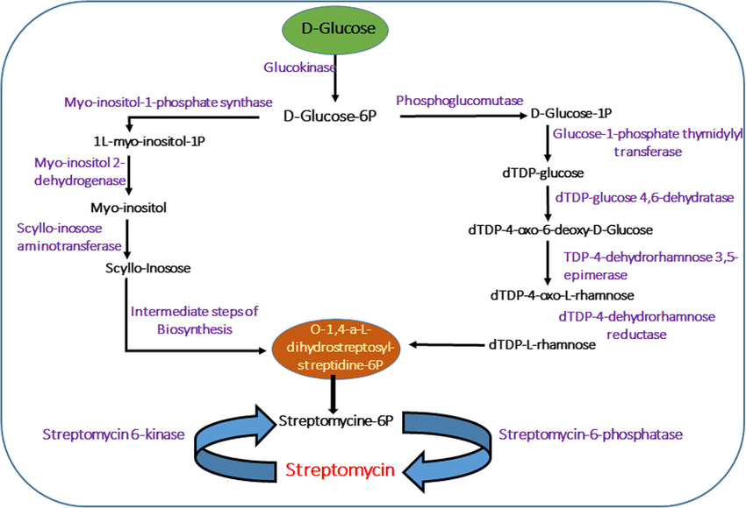
Figure 1: Streptomycin Biosynthetic Pathway in Streptomyces griseus

3.ENGINEERING PRINCIPLES OF PRODUCTION
Type of Fermenter: Mechanically agitated, aerated stirred-tank bioreactors (30,000-150,000 L) with high efficiency oxygen transfer, homogenous mixing, and precise environmental control.
Operating Conditions:
- Temperature: 28-30°C
- pH: 7.0-7.5 initially, 6.5-7.0 during production
- Aeration: >20% saturation dissolved oxygen
- Carbon Source: Glucose/starch with fed-batch feeding
- Nitrogen Source: Soybean meal, distillers' solubles, or complex organic nitrogen
- Minerals: Calcium carbonate (buffer) and regulated phosphate
- Table 1: Comparison of Streptomycin Production Parameters
Parameter | Laboratory Scale | Industrial Scale
Fermenter Volume | 5-10 L | 30,000-150,000 L
Fermentation Time | 7-10 days | 6-10 days
Temperature | 28-30°C | 28-30°C
pH Range | 7.0-7.5 | 6.5-7.5
Agitation Speed | 150-250 rpm | 200-400 rpm
Aeration Rate | 0.5-1.0 vvm | 0.5-1.5 vvm
Streptomycin Yield | 2-4 g/L | 8-12 g/L
Dissolved Oxygen | >20% saturation | >20% saturation

Downstream Processing:
- Acidification: Broth acidified to pH 2.0–3.0 for streptomycin stabilization.
- Biomass Separation: Centrifuged or rotary drum-filtered mycelial biomass.
- Ion-Exchange Chromatography: Neutral pH resin-bound cation-exchange streptomycin and eluted.
- Concentration: Vacuo-evaporated solution.
- Crystallization: Purified and crystallized as the sulfate salt or hydrochloride salt of streptomycin.
- Drying and Formulation: Freeze-dried to stable dry powder and filled for pharmaceutical purposes.
Scale-Up Challenges :
Morphological diversity to oxygen transfer, antifoam additives necessary for foam formation, maintenance of sterility by 6-10 day batch runs, phosphate control (excess suppresses biosynthesis), batch-to-batch consistency with raw materials of complex composition, and control of shear sensitivity by proper mixing.

4.INDUSTRIAL APPLICATIONS
• Major Industries: Pfizer Inc. (USA), Meiji Seika Pharma (Japan), Sanofi (France), Cipla and Lupin Pharmaceuticals (India), Chinese pharmaceutical producers.
•Commercial Products: Streptomycin sulphate injection vials (1g), penicillin combination products for veterinary use, agricultural chemicals for disease control of plants, generic tuberculosis program preparations.
•Economic and Health Importance: Transformed the treatment of tuberculosis and made actinomycetes the most productive source of antibiotics (more than two-thirds of clinically applied antibiotics). Is crucial for multidrug-resistant tuberculosis, included on WHO's List of Essential Medicines. Global market worth more than $300-400 million each year with vital significance in public health programs. Laid the groundwork for contemporary antibiotic business and proved commercial viability of microbial natural product discovery.
5.CONCLUSION
• Fermentation of streptomycin is a milestone in pharmaceutical biotechnology that illustrates the potential for soil actinomycetes to be converted into industrial production systems. Optimum strains of Streptomyces griseus were bred using mutagenesis programs and highly advanced fed-batch fermentation processes to allow mass production of this revolutionary antituberculosis agent.
• Upcoming advances hold the promise of greater productivity through synthetic biology strategies, metabolic engineering for pathway redesign, process intensification with innovative bioreactor designs, and combinatorial biosynthesis to produce new aminoglycoside derivatives with novel properties. Such advances make streptomycin fermentation continue to be of significance to clinical medicine and industrial biotechnology, especially in the treatment of the global impact of drug-resistant tuberculosis and incipient infectious diseases.
6.REFERENCES
- https://www.ncbi.nlm.nih.gov/books/NBK536909/
- https://www.who.int/publications/i/item/9789241547833
- https://www.sciencedirect.com/topics/immunology-and-microbiology/streptomycin
- https://academic.oup.com/jac/article/58/1/1/707814
- https://www.sciencedirect.com/science/article/pii/S0167779910002118

